Geospatial Approach to Solving Traffic Congestion Problems
In Mushin Local Government Area of Lagos State

Leonard M.O Aminigbo

Department of Geography and Environmental Management,
Rivers state University, Portharcourt Nigeria
and
Risu Coastal Research Group (Risu Coreg)
P. M. B. 5080, Nkpolu-0roworukwo, Rivers State, Nigeria
Email: leonard.aminigbo@ust.edu.ng, Leonardo.aminibros@gmail.com,

Abstract
The variation in road conditions in relation to traffic congestion overtime enhances the need for proper development of a geospatial platform by comprehensively building and relating the attributes information of the entire road network with respect to various road segments. This is better executed through the concept of dynamic road segmentation. The aim of this study is to carry out geospatial data structure of dynamic road segmentation in Mushin local government area of Lagos State showing the road segment (spatial data) and its topological information. The selected roads within Mushin Local Government were extracted from a street map of Mushin Local Government Area gotten from the office of the Surveyor General of Lagos state. The selected roads were digitized to obtain the spatial information required for the road segmentation. The road vectorization or digitization was carried out in ArcGIS 10.2 software. It was created as a separate shapefile and added as a layer within the GIS environment. The information acquired from the field survey describing the road network as well as the segments i.e. the attribute information, formed a database developed in a GIS platform using ArcGIS 10.2 software. This relational database contains information such as name of road, segment ID, nature of roads, nature of segments, presence of pot holes, presence of crime scenes, presence of congestion, causes of congestion, local inhabitants of segment, length of segments, adjoining land use (to the left and right), mode of transportation along the segment, the traffic condition of the roads and the number of lanes of the road. These large amount of attribute information for all the segment were geospatially referenced with respect to the positions of all the segments and this is the basis of every GIS operation; providing an environment for relating the spatial locations of features with the attribute information describing the spatial feature (which in this case the roads and the road segments represents the spatial feature). Spatial query by attribute as well as location can easily be carried out to select road segments of interest based on predefined criteria using a specific Structural Query Language (SQL) within the GIS environment. Dynamic road segmentation provides a platform for planning and controlling changes on road network. Since the roads are broken down into segments, temporal changes of the road structure as well as the traffic conditions of the roads can be analysed and suitable decisions as well as policies for proper road maintenance can easily be taken and the policies implemented with respect to the segmentation of the roads. It also aids the security organization implementing platform within a GIS environment to monitor the crime scenes with respect to affected segment and would aid in the deployment of security agents at the appropriate locations in case of emergency. In the control of traffic, dynamic road segmentation aid in deciding the alternative conditions to follow since the entire road network have being spatially segmented and the conditions of all the segments built into the GIS database.

- Introduction
Spatial data are data that are geographically referenced and interconnected. The dynamic nature of a road network depicts an interconnected spatial data, structurally represented by the various categories of the roads. These roads are characterized by both spatial and attribute information. The attribute information of the roads include information such as presence of pot hole, congestion point, adjoining land uses, presence of crime scene, number of lanes of the road , the transport mode of the road etc., and these information varies from segment to segment of the entire road network. In developing the spatial data structure of the road, a segmentation of the road network into the nature/condition of individual segment is required.
Furthermore, the proper monitoring and managements of a network of roads requires a proper development of a spatial data structure of the road dynamics. This is easily achieved within the GIS environment by carrying out a dynamic segmentation of the road network with reference to all the spatial and attributes information of the roads.
Dynamic road segmentation is the process of computing the map locations of linearly referenced data (for example, attributes stored in a table) at run time so they can be displayed on a map, queried, and analysed using a GIS tool. The dynamic segmentation process enables multiple sets of attributes to be associated with any portion of a line feature without segmenting the underlying feature. In the field of transportation geography, examples of such linearly referenced data might include accident sites, road quality, and traffic volume.
Dynamic segmentation has being applied in the study of road transportation by various authors availing the advantage of the road existing as a series of geospatial objects and features which are linked to linear spatial objects by “distance referencing”; as a fundamental concept of dynamic segmentation. Dueker (1987) identified run-time segmentation using distance referencing as a solution to the problem of overlapping attribute data. Nyerges (1990), elaborated dynamic segmentation by modelling highway routes as linear spatial objects.
The variation in the road conditions overtime enhances the need for proper development of a GIS platform by comprehensively building and relating the attributes information of the entire road network with respect to various road segments. This is better executed through the concept of dynamic road segmentation.
The aim of the study is to carry out spatial data structures of dynamic road segmentation in Mushin local government of Lagos state showing the road segment (spatial data) and its topological information
The objectives therefore are as follows;
- To obtain the spatial information of the selected roads in the study area by digitizing them from a base map.
- To carry out a dynamic road segmentation of all entire road network.
- To carry out an arc-node topology of the road segmentation
- To determine the traffic volume conditions of the selected roads.
- To determine crime spot, potholes, congestion spot, and police post in the study area

Study Area
The study area of this project is Mushin Local Government Area, in Lagos State, South-Western, Nigeria. It covers an area of 8.66 Sq. kilometres and it is bounded to the north by Ikeja Local Government Area, to the east by Somolu LGA, to the west by Oshodi Isolo LGA and to the south by Surulere LGA, while it’s perimeter is given as 11.52 kilometres. It lies between latitude 6º 31’ 45” and Longitude 3º 21’ 18”. Mushin Local Government Area can be described as a mixed settlement; because the area serves as a commercial centre and also as a residential area. The areas that constitute the Local Government Area are: Mushin, Ilasamaja, Idi-Araba, Ilupeju, Palm Avenue etc.
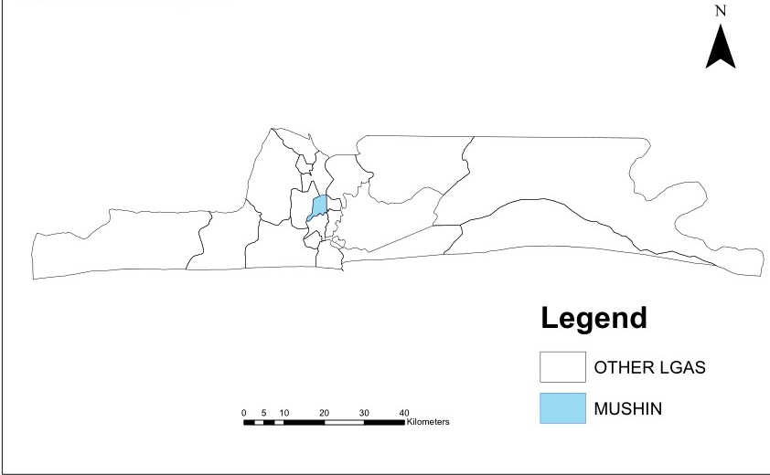
Figure 1: Map of Lagos State showing study area
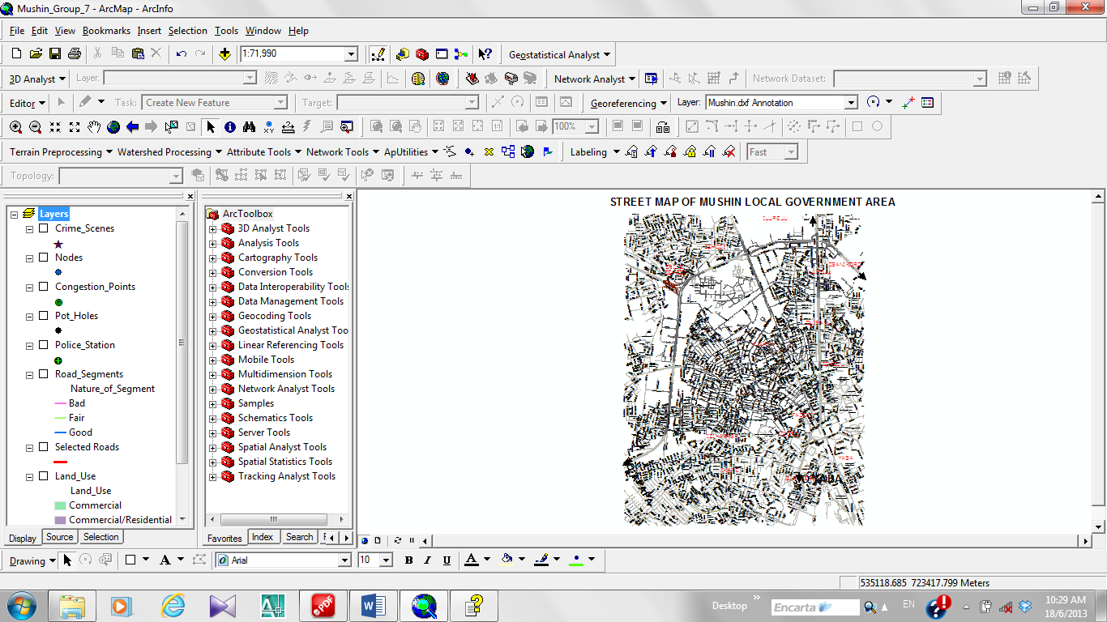
Figure 2: Image of Street Map of mushin Local Government in ArcGIS Environment

- Literature Review
Dynamic segmentation is the process of transforming linearly referenced data (also known as events) that have been stored in a table into features that can be displayed and analyzed on a map. For example, a utility company may segment transmission pipes dynamically according to the quality of the pipe. Attribute information describing quality characteristics specific to each pipeline segment can then be maintained without splitting the pipeline network. The dynamic segmentation process imposes two requirements on the data. Each event in an event table must include a unique identifier and position along a linear feature. Each linear feature must have a unique identifier and measurement system.(Jennifer Cadkin, ESRI Technical Industry Marketing Specialist).
GIS vendors are incorporating Dynamic Segmentation into their repertoire in response to the needs of transportation organizations. (Kenneth J. Duecker. Dynamic Segmentation Revisited)
A Geographic Information System (GIS) is a system designed to capture, store, manipulate, analyze, manage, and present all types of geographical data. The acronym GIS is sometimes used for geographical information science or geospatial information studies to refer to the academic discipline or career of working with geographic information systems and is a large domain within the broader academic discipline of Geoinformatics. In the simplest terms, GIS is the merging of cartography, statistical analysis, and computer science technology.
A GIS can be thought of as a system that digitally creates and "manipulates" spatial areas that may be jurisdictional, purpose, or application-oriented. Generally, a GIS is custom-designed for an organization. Hence, a GIS developed for an application, jurisdiction, enterprise, or purpose may not be necessarily interoperable or compatible with a GIS that has been developed for some other application, jurisdiction, enterprise, or purpose.
In a general sense, the term describes any information system that integrates stores, edits, analyzes, shares, and displays geographic information for informing decision making. GIS applications are tools that allow users to create interactive queries (user-created searches), analyze spatial information, edit data in maps, and present the results of all these operations.
GIS is a relatively broad term that can refer to a number of different technologies, processes, and methods. It is attached to many operations and has many applications related to engineering, planning, management, transport/logistics, insurance, telecommunications, and business. For that reason, GIS and location intelligence applications can be the foundation for many location-enabled services that rely on analysis, visualization and dissemination of results for collaborative decision making.

3. Material and Method

3.1. Reconnaissance
This is the preliminary stage of the entire study which involves the categorization of data required and the pattern of observation. The flow pattern of the methodology and nature of data analysis was sequentially developed for easy execution of the project. The flow chart below represents a model of the spatial data structure of dynamic road segmentation carried out in this research work.
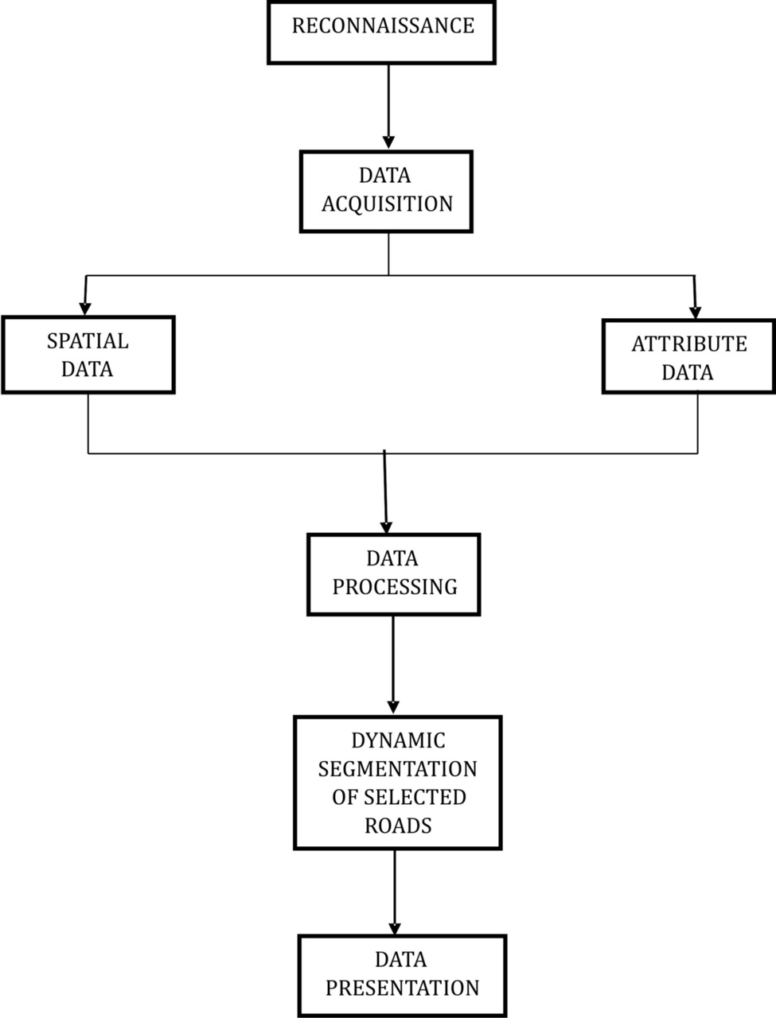
Figure 3: Flowchart Showing Model of Work Flow.

3.2 Digitizing of the Base Map
The selected roads within Mushin Local Government were extracted from a street map of Mushin Local Government Area gotten from the office of the Surveyor General of Lagos state. The selected roads were digitized to obtain the spatial information required for the road segmentation. The road vectorization or digitization was carried out in ArcGIS 10.2 software. It was created as a separate shapefile and added as a layer within the GIS.
The following are the roads selected within the local government.
- Ikorodu road
- Agege Motor Road
- Isolo Road
- Fatai Atere Road
- Palm Avenue
- Itire Road (I)
- Itire Road (II)
- Apapa - Oshodi Express
- Oshodi - Oworonshoki Express
- Ladipo Road
- Town Planning Way

3.3 Segmentation of the Selected Roads
The selected roads were traversed with public transport during which we segmented the roads with respect to notable junctions as well as popular bus stops. The spatial information of these points i.e. the X, Y coordinate were acquired with a hand held GPS and they form the nodes of the required road segmentation. The coordinates of these points were imported into ARCGIS 10.2 software and exported as shapefile with the name nodes. The nodes fell on the digitized selected roads and were connected together with a separate shapefile feature called segments overlaid on the selected roads. Segments of the roads was created using well recognized bus-stops and terminals for most of the roads
The above operations lead to the development of an arc-node topology defined by the nodes and the segments. The roads were divided into 50 segments.

3.4. The nature of each segment
Information describing the nature of each individual segment includes the presence of crime scene, congestion points, presence of pot holes and the segment general structural condition. The general structural condition of the road was noted and the location of pot holes, congestion point as well as crime scenes were taken with the GPS. These coordinates were also imported into the GIS environment.

3.5. Other Attribute information of the roads and the segment.
Other attribute information noted here include the number of lanes of the roads, the mode of transportation, the local inhabitants of each segment, the land use to the left and right sides of the segments, the travel time of the segment and the traffic condition of the roads.
The traffic condition of the eleven selected roads was observed at an hourly basis for weekend (Saturday) and weekday (Monday). The traffic observation was carried out for four days. The traffic observation table is attached to this port as appendix.

3.6. The Database of the attribute information
The entire attribute information acquired for all the roads and the segments were presented in a relational database in the GIS environment. The entire work is saved in a CD drive and the database of information can be assessed. The print screen below shows part of the database of the attribute data. The database of the road segments has also being attached to the report as appendix.
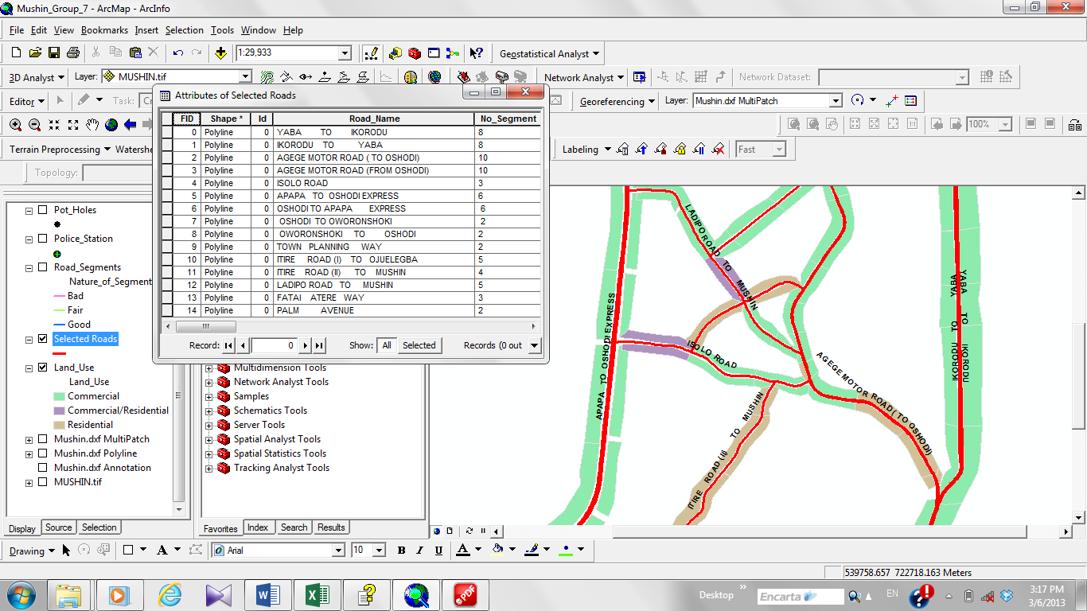
Figure 4: showing five fields (just a part) of the database for the entire road network.
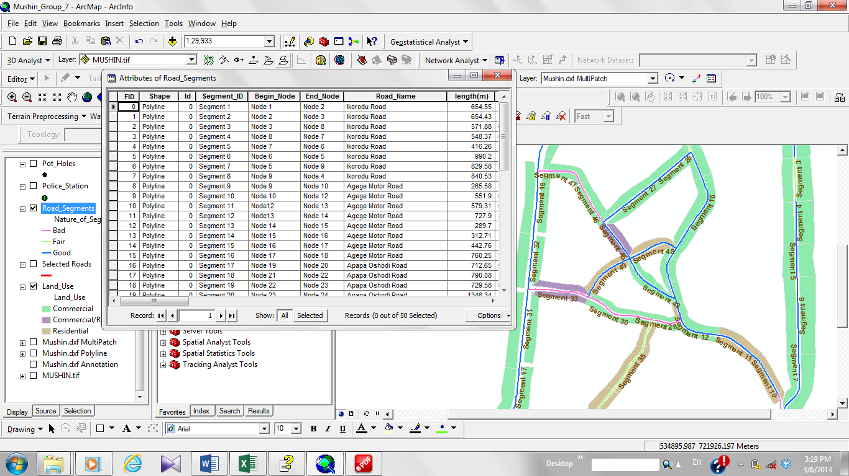
Figure 5: Showing eight fields (just a part) of the database of the road segments.

4. Result and Analysis

4.1. Database of Road Segmentation
The information acquired from the field survey describing the road network as well as the segments i.e. the attribute information, are built in a database developed in a GIS platform using ArcGIS 10.2 software. This relational database contains information such as name of road, segment ID, nature of roads, nature of segments, presence of pot hole, presence of crime scenes, presence of congestion, causes of congestion, local inhabitants of segment, length of segments, adjoining land use (to the left and right), mode of transportation along the segment, the traffic condition of the roads and the number of lanes of the road.
These large amount of attribute information for all the segment were spatially reference with respect to the positions of all the segments and this is the basis of every GIS operation; providing an environment for relating the spatial locations of features with the attribute information describing the spatial feature (which in this case the roads and the road segments represents the spatial feature)
Spatial query by attribute as well as location can be easily be carried out to select road segments of interest based on a predefined criteria using a specific Structural Query Language (SQL) within the GIS environment.

4.2. Dynamic Segmentation of the Road Network
The entire road network was dynamically segmentated in the ArcGIS environment. This segmentation resulted in grouping the entire roads into three categories; “good” (the blue line), “fair” (the green line) and “bad” (the pink colour). This dynamic segmentation enables users to easily access the information describing the conditions of the roads.
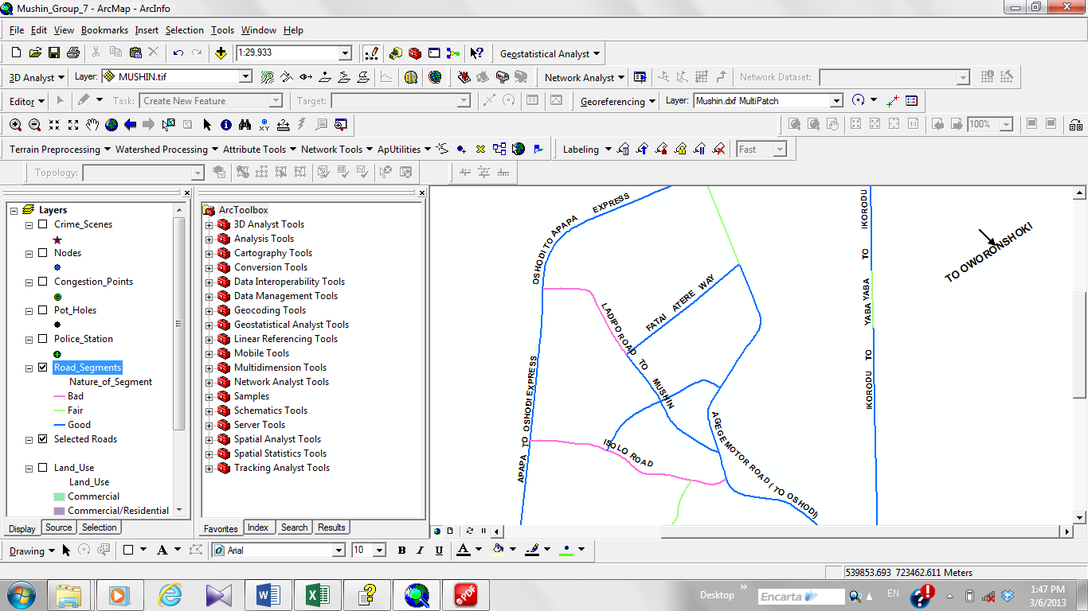
Figure 6: Showing dynamic segmentation of the road network.
Furthermore a dynamic segmentation query was also executed to show road segment prone to traffic congestion and otherwise. This geoprocessing operation executed indicates the road segment prone to congestion in red and those not prone to traffic congestion in blue. However the congestion is dependent on the time of observation of the day. The traffic congestion was observed to be high in the morning and picks up later in the evening due to the rush to work and the rush to home from offices respectively.
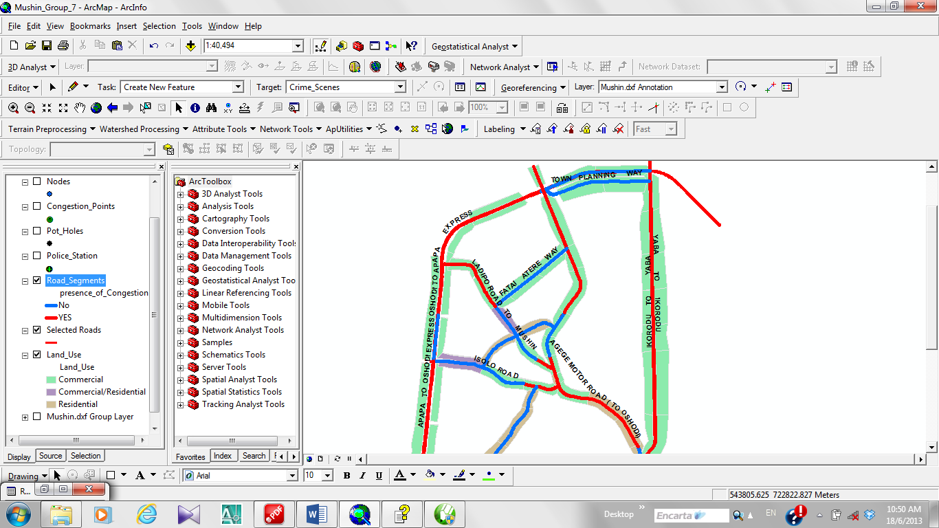
Figure 7: Showing regions of roads prone to traffic congestion

4.3. Arc-Node Topology of the Road Network.
The dynamic road segmentation of the selected roads was analyzed using Arc-Node Topology. This was carried out by breaking individual roads into segments. Each segment consists of nodes and arc. The nodes are well defined by X, Y Cartesian coordinates and connected by the line segment (of specified length) usually referred to as arc in topological decomposition. These present the spatial frame work of the roads clearly indicating its dynamic nature as we move from segment to segment. The visual representation of the arc node topology of the road network is printed as a map and attached in the report.
The Topological decomposition is important as it clearly breaks down the roads into segments and segment with bad conditions can be easily rehabilitated. The land used at adjoining side of each segment is clearly represented in the topology.
Presented in tabular form below is a summary of the arc-node topology on the selected roads studied in Mushin Local Government Area of Lagos State.

Table 1. Ikorodu Road (8 Segments)
SEGMENTS ID (ARCS) | BEGINNING NODE | ENDING NODE | LEFT LAND USE | RIGHT LAND USE
Segment 1 | Node 1 | Node 2 | Commercial | Commercial
Segment 2 | Node 2 | Node 3 | Commercial | Commercial
Segment 3 | Node 3 | Node 8 | Commercial | Commercial
Segment 4 | Node 8 | Node 7 | Commercial | Commercial
Segment 5 | Node 7 | Node 6 | Commercial | Commercial
Segment 6 | Node 6 | Node 5 | Commercial | Commercial
Segment 7 | Node 5 | Node 9 | Commercial | Commercial
Segment 8 | Node 9 | Node 4 | Commercial | Commercial

Table 2: Apapa - Oshodi Express (6 Segments)
SEGMENTS ID(ARCS) | BEGINNING NODE | ENDING NODE | LEFT LAND USE | RIGHT LAND USE
Segment 17 | Node 19 | Node 20 | Commercial | Commercial
Segment 31 | Node 20 | Node 35 | Commercial | Commercial
Segment 32 | Node 35 | Node 21 | Commercial | Commercial
Segment 18 | Node 21 | Node 22 | Commercial | Commercial
Segment 19 | Node 22 | Node 23 | Commercial | Commercial
Segment 20 | Node 23 | Node 24 | Commercial | Commercial

Table 3. Agege Motor Road (10 Segments)
SEGMENTS ID(ARCS) | BEGINNING NODE | ENDING NODE | LEFT LAND USE | RIGHT LAND USE
Segment 9 | Node 9 | Node 10 | Commercial | Commercial
Segment 10 | Node 10 | Node 12 | Commercial | Commercial
Segment 11 | Node 12 | Node 13 | Commercial | Commercial
Segment 12 | Node 13 | Node 14 | Residential | Commercial
Segment 13 | Node 14 | Node 15 | Commercial | Commercial
Segment 14 | Node 15 | Node 16 | Commercial | Commercial
Segment 15 | Node 16 | Node 17 | Commercial | Commercial
Segment 16 | Node 17 | Node 18 | Commercial | Commercial
Segment 24 | Node 18 | Node 28 | Commercial | Commercial
Segment 25 | Node 28 | Node 11 | Commercial | Commercial

Table 4. Oshodi - Oworonshoki Express (2 Segments)
SEGMENTS ID(ARCS) | BEGINNING NODE | ENDING NODE | LEFT LAND USE | RIGHT LAND USE
Segment 21 | Node 24 | Node 50 | Commercial | Commercial
Segment 50 | Node 50 | Node 1 | Commercial | Commercial

Table 5. Isolo Road (3 Segments)
SEGMENTS ID(ARCS) | BEGINNING NODE | ENDING NODE | LEFT LAND USE | RIGHT LAND USE
Segment 29 | Node 33 | Node 32 | Commercial | Commercial
Segment 30 | Node 32 | Node 34 | Commercial | Commercial
Segment 33 | Node 34 | Node 35 | Commercial/Residential | Commercial/Residential

Table 6: Town Planning Way (2 Segments)
SEGMENTS ID(ARCS) | BEGINNING NODE | ENDING NODE | LEFT LAND USE | RIGHT LAND USE
Segment 22 | Node 25 | Node 26 | Commercial | Commercial
Segment 23 | Node 26 | Node 27 | Commercial | Commercial

Table 7: Palm Avenue (2 Segments)
SEGMENTS ID(ARCS) | BEGINNING NODE | ENDING NODE | LEFT LAND USE | RIGHT LAND USE
Segment 48 | Node 49 | Node 46 | Residential | Residential
Segment 49 | Node 46 | Node 34 | Residential | Residential

Table 8: Itire Road (I) (5 Segments)
SEGMENTS ID(ARCS) | BEGINNING NODE | ENDING NODE | LEFT LAND USE | RIGHT LAND USE
Segment 38 | Node 4 | Node 44 | Commercial | Commercial
Segment 39 | Node 44 | Node 43 | Commercial | Commercial
Segment 40 | Node 43 | Node 42 | Commercial | Commercial
Segment 41 | Node 42 | Node 40 | Commercial | Commercial
Segment 42 | Node 40 | Node 41 | Commercial | Commercial

Table 9: Itire Road (II) (4 Segments)
SEGMENTS ID(ARCS) | BEGINNING NODE | ENDING NODE | LEFT LAND USE | RIGHT LAND USE
Segment 34 | Node 36 | Node 37 | Residential | Residential
Segment 35 | Node 37 | Node 38 | Residential | Residential
Segment 36 | Node 38 | Node 39 | Residential | Residential
Segment 37 | Node 39 | Node 40 | Residential | Residential

Table 10: Ladipo Road (5 Segments)
SEGMENTS ID(ARCS) | BEGINNING NODE | ENDING NODE | LEFT LAND USE | RIGHT LAND USE
Segment 43 | Node 48 | Node 47 | Commercial | Commercial
Segment 44 | Node 47 | Node 46 | Commercial | Commercial
Segment 45 | Node 46 | Node 31 | Residential/Commercial | Residential/Commercial
Segment 46 | Node 31 | Node 45 | Residential/Commercial | Residential/Commercial
Segment 47 | Node 45 | Node 22 | Commercial | Commercial

Table 11: Fatai Atere Way (3 Segments)
SEGMENTS ID(ARCS) | BEGINNING NODE | ENDING NODE | LEFT LAND USE | RIGHT LAND USE
Segment 26 | Node 31 | Node 29 | Commercial | Commercial
Segment 27 | Node 29 | Node 30 | Commercial | Commercial
Segment 28 | Node 30 | Node 28 | Commercial | Commercial

The above eleven tables represent the arc-node decomposition of the eleven roads selected within the study area. The coordinates of the nodes joining the respective segments are presented in Appendix A while the length of all the segments is represented in Appendix B. The left and right land uses of the segments are represented as polygon features in the arc map environment and can be visualized in the GIS environment.

4.4. Presentation of the Road Segmentation
The visual representations of the spatial features describing the dynamic road segmentation i.e. the roads, the road segments, the nodes, crime scenes, police station, congestion point, pothole location and the land use are presented pictorially as maps in four category as:
- Map showing the selected roads within Mushin Local Government Area.
- Map showing the dynamic segmentation of the selected roads into arcs and nodes within Mushin Local Government Area.
- Map showing the dynamic segmentation of the selected roads with adjoining land use
- Traffic Map showing regions of the selected road prone to traffic congestion.
Copies of these maps are attached to this report for visualization.

Conclusion
Dynamic road segmentation provides a platform for planning and controlling changes on road network. Since the roads are broken down into segments temporal changes of the road structure as well as the traffic conditions of the roads can be analysed and suitable decisions as well as policies for proper road maintenance can be easily taken and the policies implemented with respect to the segmentation of the roads.
It also aids the security organization implementing platform within a GIS environment to monitor the crime scenes with respect to affected segment and would aid in the deployment of security agents at the appropriate locations in case of emergency.
In the control of traffic, dynamic road segmentation aid in deciding the alternative conditions to follow since the entire road network have being spatially segmented and the conditions of all the segments built into the GIS database.

Reference
Alberta Infrastructure and Transportation. 2006. Alberta Highway Guide and Information Sign Manual, Alberta Infrastructure and Transportation. www.transportation.alberta.ca. Accessed 25th January, 2000.
Berkeley, CA.(Lecture Notes in Computer Science 337, Springer-Verlag, Berlin, 1988).
Bayliss, D. (1977), Urban Transportation Research Priorities Transportation Network and Traffic In Town. Pg4– 17.
Bhawani, C. 2014. What is GPS – How does it work, and what are its types? https://phoneradar.com/gps-global-positioning-system/. Accessed 27th March, 2020.
Buchmann, A., Gunther, O., Smith, T. R., and Wang, Y.F., Eds. 1990. : Design and Implementation of Large Spatial Databases, Lecture Notes in Computer Science 409. Springer-Verlag, Berlin.
Dueker, K. J., “Geographic Information Systems and Computer-Aided Mapping,” Journal of the American Planning Association, summer, 1987.
Environmental Systems Research Institutes (ESRI) 2008.
Escobar, F., G. Hunter, I. Bishop and A. Zeger. 2020. Introduction to GIS. Department of Geomatics, The University of Melbourne http://www.sli.unimelb.edu.au/gisweb/. Accessed 27th March, 2020.

Federal Highway Administration. 2009. Manual on Uniform Traffic Control Devices. US Department of Transportation, Federal Highway Administration, USA.
Federal Ministry of Works. 2013. Highway Manual Part 1: Design Vol. VI, Road Traffic Signs and Road Markings. Federal Ministry of Works, Nigeria.
Government of Alberta. 2005. Placement of Signs. http://www.transportation.alberta.ca/Content/docType233/Production/29SignPlacement -General.pdf. Accessed 3rd February, 2019.
Goodchild, M.F., and K.K. Kemp. 1990. NCGIA Core Curriculum in GIS https://geogra.uah.es/patxi/gisweb/GISModule/GISTheory.htm. Accessed 27th March, 2020.
Gunther, O. 1988. “Efficient structures for geometric data management.” PhD thesis, Electronics Research Laboratory, College of Engineering, University of California at Berkeley,
Kombs (1988), Consultancy Report: Traffic Management Schemes in Metropolitan Lagos. Submitted to the Federal Urban Mass Transit Programme (FUMTP)
Kiema, J. B. K and J. M. Mwangi. 2009. A Prototype GIS-based Road Pavement Information and Management System. Journal of Civil Engineering Research and Practice, 6(1): 79-90
Microsoft Encarta, 2009
National Population Commission (2006), National Population Census of the Federal Republic of Nigeria: 2006 Census Final Results, Lagos State.
Nigerian National Council on Works. 2017. Communiqué of the 23rd Meeting of The National Council On Works, Nigeria, Held at The NAF Conference Centre, Kado District, Federal Capital Territory, Abuja, Nigeria, Federal Ministry of Works, Nigeria.
Ng, A. W., and A. H. Chan. 2008. The Effects of Driver Factors and Sign Design Features on the Comprehensibility of Traffic Signs. Journal of Safety Research, 39(3): 321-328.
Nyerges, T. L., “Location Referencing and Highway Segmentation in a GIS for Transportation,” ITE Journal, March, 1990.
Ogden, M. A., K. N. Womack and J. M. Mounce. 1990. Motorist Comprehension of Signing Applied in Urban Arterial Work Zones. Transportation Research Record, 1281: 127- 135.
Pandey, J. and D. P. Joshi. 2011. GIS Based Road Information and Management System: A Case Study of 2010 Disaster in Uttarakhand. Journal of Engineering Research and Studies, 2(3): 124 - 127
Pour-Rouholamin, M., and H. Zhou. 2016. Investigating the Risk Factors Associated with Pedestrian Injury Severity in Illinois. Journal of Safety Research, 57: 9-17.

Praprut, S and P. M. Adam. 2011. Guidance for Cost-Effective Selection of Pavement Marking Materials for Work Zones. Journal of Infrastructure Systems, 17: 55-65.
Punch 2019. https://punchng.com/firm-unveils-made-in-nigeria-road-marking-paint. Accessed 3rd January 2019.
Rahman, S. A. U. and A. K. Duggal. 2015. Suitability of Different Materials Used for Road Marking: A Review. International Research Journal of Engineering and Technology (IRJET), 02(02): 622-625.
Texas Department of Transportation. 2004. Pavement Marking Handbook. Texas Department of Transportation, USA.
United Nations. 1968. Vienna Convention

Copyrights
Copyright for this article is retained by the author(s), with first publication rights granted to the journal.
This is an open-access article distributed under the terms and conditions of the Creative Commons Attribution license (http://creativecommons.org/licenses/by/4.0/)

